Dear [Primary Auditee]

This email is to notify you that as part of the Internal Audit plan for the year 20XX, Group Audit intends to carry out an audit of (Audit Title).

Group Audit will contact you soon to start arranging for Audit Planning activities, including meetings and walkthroughs with key staff and requests for information.

Upon conclusion of the planning phase, Group Audit will issue a Terms of Reference outlining the Audit’s objective, scope and timelines. Group Audit intends to start the planning phase of the audit by [date] and to issue the Terms of Reference by [date].

Any relevant issues, including those self-identified, that are available in the GRC Tool prior to start of audit planning will be assessed during the audit to:

* validate the appropriateness of action plans, ownership, risk rating and target dates
* determine the impact on the overall control environment
* avoid duplication

Group Audit will not consider any self-identified issues logged in the GRC tool after the start date of the audit.

Please let us know should you have any questions.

Thank you in advance for your cooperation,

Kind regards,

[Lead Auditor]

Board Meeting Minutes:

* We discussed long term strategy for expanding into Japan and Australia
* We approved budget for above said expansion.
* All members were happy to award annual bonus equal to 12 salaries for 2024.

Meeting ended.

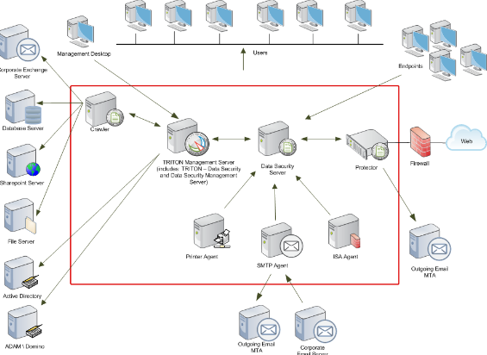

Upon conclusion of the planning phase, Group Audit will issue a Terms of Reference outlining the Audit’s objective, scope and timelines. Group Audit intends to start the planning phase of the audit by [date] and to issue the Terms of Reference by [date].

Any relevant issues, including those self-identified, that are available in the GRC Tool prior to start of audit planning will be assessed during the audit to:

* validate the appropriateness of action plans, ownership, risk rating and target dates
* determine the impact on the overall control environment
* avoid duplication

Group Audit will not consider any self-identified issues logged in the GRC tool after the start date of the audit.

Upon conclusion of the planning phase, Group Audit will issue a Terms of Reference outlining the Audit’s objective, scope and timelines. Group Audit intends to start the planning phase of the audit by [date] and to issue the Terms of Reference by [date].

Any relevant issues, including those self-identified, that are available in the GRC Tool prior to start of audit planning will be assessed during the audit to:

* validate the appropriateness of action plans, ownership, risk rating and target dates
* determine the impact on the overall control environment
* avoid duplication

Group Audit will not consider any self-identified issues logged in the GRC tool after the start date of the audit.

Upon conclusion of the planning phase, Group Audit will issue a Terms of Reference outlining the Audit’s objective, scope and timelines. Group Audit intends to start the planning phase of the audit by [date] and to issue the Terms of Reference by [date].

Any relevant issues, including those self-identified, that are available in the GRC Tool prior to start of audit planning will be assessed during the audit to:

* validate the appropriateness of action plans, ownership, risk rating and target dates
* determine the impact on the overall control environment
* avoid duplication

Group Audit will not consider any self-identified issues logged in the GRC tool after the start date of the audit.

Upon conclusion of the planning phase, Group Audit will issue a Terms of Reference outlining the Audit’s objective, scope and timelines. Group Audit intends to start the planning phase of the audit by [date] and to issue the Terms of Reference by [date].

Any relevant issues, including those self-identified, that are available in the GRC Tool prior to start of audit planning will be assessed during the audit to:

* validate the appropriateness of action plans, ownership, risk rating and target dates
* determine the impact on the overall control environment
* avoid duplication

Group Audit will not consider any self-identified issues logged in the GRC tool after the start date of the audit.



* validate the appropriateness of action plans, ownership, risk rating and target dates
* determine the impact on the overall control environment
* avoid duplication

Group Audit will not consider any self-identified issues logged in the GRC tool after the start date of the audit.

Upon conclusion of the planning phase, Group Audit will issue a Terms of Reference outlining the Audit’s objective, scope and timelines. Group Audit intends to start the planning phase of the audit by [date] and to issue the Terms of Reference by [date].

Any relevant issues, including those self-identified, that are available in the GRC Tool prior to start of audit planning will be assessed during the audit to:

* validate the appropriateness of action plans, ownership, risk rating and target dates
* determine the impact on the overall control environment
* validate the appropriateness of action plans, ownership, risk rating and target dates
* determine the impact on the overall control environment
* avoid duplication

Group Audit will not consider any self-identified issues logged in the GRC tool after the start date of the audit.

Upon conclusion of the planning phase, Group Audit will issue a Terms of Reference outlining the Audit’s objective, scope and timelines. Group Audit intends to start the planning phase of the audit by [date] and to issue the Terms of Reference by [date].

Any relevant issues, including those self-identified, that are available in the GRC Tool prior to start of audit planning will be assessed during the audit to:

* validate the appropriateness of action plans, ownership, risk rating and target dates
* determine the impact on the overall control environment
* validate the appropriateness of action plans, ownership, risk rating and target dates
* determine the impact on the overall control environment
* avoid duplication

Group Audit will not consider any self-identified issues logged in the GRC tool after the start date of the audit.

Upon conclusion of the planning phase, Group Audit will issue a Terms of Reference outlining the Audit’s objective, scope and timelines. Group Audit intends to start the planning phase of the audit by [date] and to issue the Terms of Reference by [date].

Any relevant issues, including those self-identified, that are available in the GRC Tool prior to start of audit planning will be assessed during the audit to:

* validate the appropriateness of action plans, ownership, risk rating and target dates
* determine the impact on the overall control environment
* validate the appropriateness of action plans, ownership, risk rating and target dates
* determine the impact on the overall control environment
* avoid duplication

Group Audit will not consider any self-identified issues logged in the GRC tool after the start date of the audit.

Upon conclusion of the planning phase, Group Audit will issue a Terms of Reference outlining the Audit’s objective, scope and timelines. Group Audit intends to start the planning phase of the audit by [date] and to issue the Terms of Reference by [date].

Any relevant issues, including those self-identified, that are available in the GRC Tool prior to start of audit planning will be assessed during the audit to:

* validate the appropriateness of action plans, ownership, risk rating and target dates
* determine the impact on the overall control environment

Financial Result 2025:

Profit margins will increase by 145 %,

Two more banks will be acquired in Japan.

Salaries will be increased by 35% with effect from 1st July 2024.ent Upon conclusion of the planning phase, Group Audit will issue a Terms of Reference outlining the Audit’s objective, scope and timelines. Group Audit intends to start the planning phase of the audit by [date] and to issue the Terms of Reference by [date].

Any relevant issues, including those self-identified, that are available in the GRC Tool prior to start of audit planning will be assessed during the audit to:

